September 27, 2022

WORLD’S BRIGHTEST AUTOMOVING DRONE LIGHT FOR ALL DJI MAVIC 3 drones (M3, M3E, M3T)

Tundra Drone’s 10,000 lumens bright Automoving light for all models of DJI Mavic 3 (M3, M3E, M3T) provides enhanced illumination for critical drone operations in the dark and in low light conditions. The auto-moving drone light is suitable for public safety operations, inspection work and commercial use.

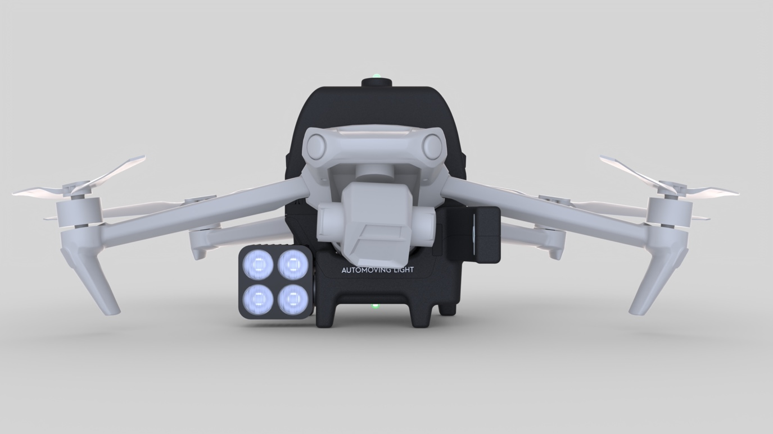
Image: Tundra Drone Automoving light for DJI Mavic 3 (Mavic 3, Mavic 3E, Mavic 3T). Credits: Tundra Drone AS

Enhanced lighting for critical applications at night
It’s difficult to use drones in the dark and in low light conditions. We struggle with this every winter in the Arctic circle in Norway when we have three months of no sunlight. That’s why we invented the Automoving light, says CTO and co-founder of Tundra Drone, Tim Valio.

With enhanced lighting from the Automoving light, all the DJI Mavic 3 drones can now be used for many critical applications at night. Search and rescue teams can now use drones to locate missing persons and save people’s lives. Law enforcement and fire fighters can get lighting where they need it the most. When a storm causes power outages, drones with lighting can be used to quickly locate and inspect utility poles that need to be repaired quickly. The Automoving light is suitable for many commercial drone applications at night, says Tor Erik Somby, CEO and co-founder of Tundra Drone.

Illuminates a 14X larger area than a non-moving fixed spotlight
The Automoving light uses computer vision to automatically track the drone camera’s movements and provides optimal illumination in every angle and field of view. By using our patented Automoving technology, we can illuminate a 14X larger area than a non-moving fixed spotlight, says Tim Valio.

The brightest drone light in the market
With 10 000 lumens, drone pilots will get a good overview in the dark and be able to operate much like in daylight. This is the brightest auto-moving drone light for DJI Mavic 3 and Mavic 2 drones on the market, Tor Erik Somby says.

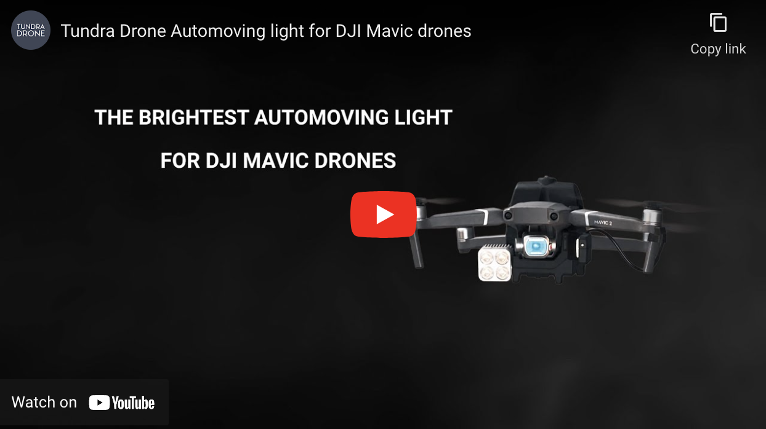
Video: Product video of Automoving light for all DJI Mavic 2 and Mavic 3 (Mavic 3, Mavic 3E, Mavic 3T). Video URL: https://youtu.be/24rSkZy6LLk
Credits: Tundra Drone AS

Lighting as long as the drone flies
In full brightness, the battery of the Automoving light will last as long as a drone battery. It can be swapped at the same time as the drone’s battery. The flight time is thus limited only by the number of batteries to the drone and the light. The drone pilot can use the drone’s own remote controller to turn the light on/off when needed.

Cost-effective solution
In many cases, this cost-effective solution could replace the need for large professional drone solutions, use of helicopter, or inefficient third-party (non-moving) lighting. Tundra Drone offers complete tactical responder kits for DJI Mavic 3:

Kit for small operations | Kit for large operations
1 Automoving light  3 Batteries  1 Battery charger  1 Car charger 12V  1 Transportation case (small)  Introduction price¹: $1,490  Retail price: $1,690 | 1 Automoving light  6 Batteries  1 Battery charger  1 Car charger 12V  1 Battery charger hub  1 Transportation case (large)  Introduction price¹: $1,650  Retail price: $1,910

¹: Introduction price until October 31st, 2022. All prices stated excluding VAT.

Available now in the US market
Current delivery time is approx. 4 weeks from the time of order. Tundra Drone is partnering with enterprise drone dealers in the US to ensure a wider availability and faster delivery. More information about partners will be published on tundradrone.com.

Contact information

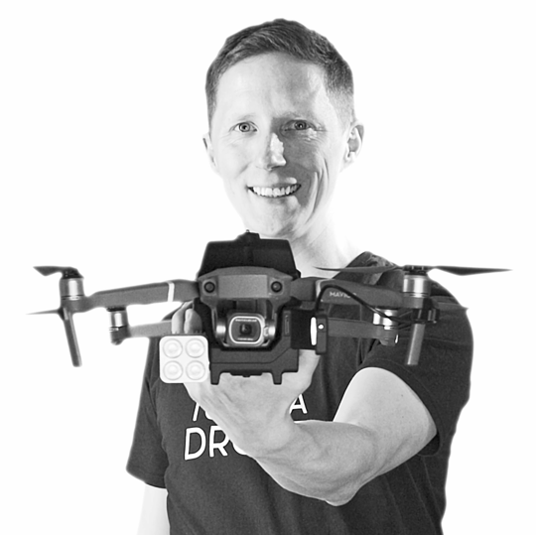 | Tor Erik Somby  CEO & Co-founder  Tundra Drone AS  Email: mail@tundradrone.com  Web: https://tundradrone.com

About Tundra Drone
Tundra Drone makes pioneering payloads for prosumer drones for the global market. The products are designed in Norway and manufactured in EU. The company was established in 2019 by the founders and drone pilots, Tim Valio and Tor Erik Somby. Tim Valio holds a master’s degree in electronics engineering and Tor Erik Somby has a master’s degree in marketing. The Tundra Drone team also consists of a red-dot award winning product designer, several investors and a professional board of directors that support the future growth and development of the company. Today the company also gets support from mentors in the Silicon Valley based company BMNT to enter the US market.

PRESS KIT

Images and videos

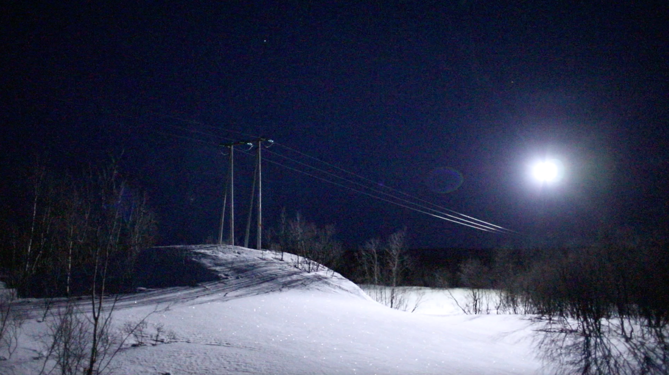
Video screenshot: Automoving light being used in different test flights
Video URL: https://youtu.be/EbcJVgC6in0
Credits: Tundra Drone AS

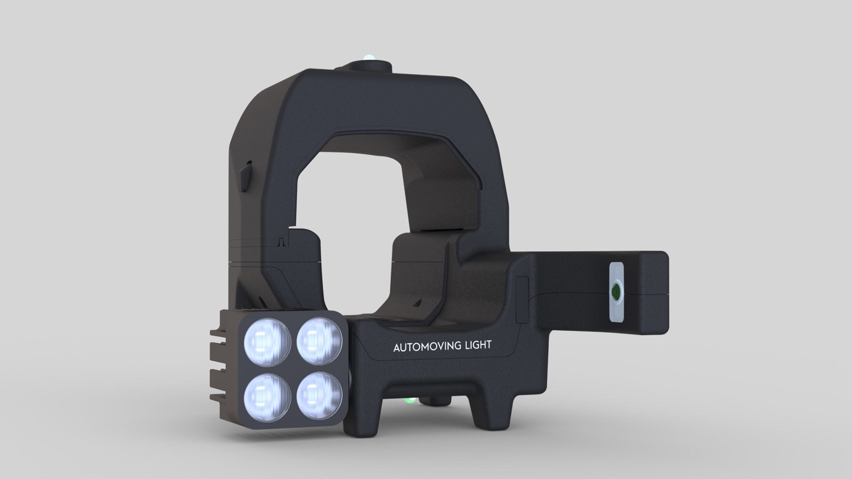
Image: Tundra Drone Automoving light for DJI Mavic 3, Mavic 3E and Mavic 3T.
Credits: Tundra Drone AS

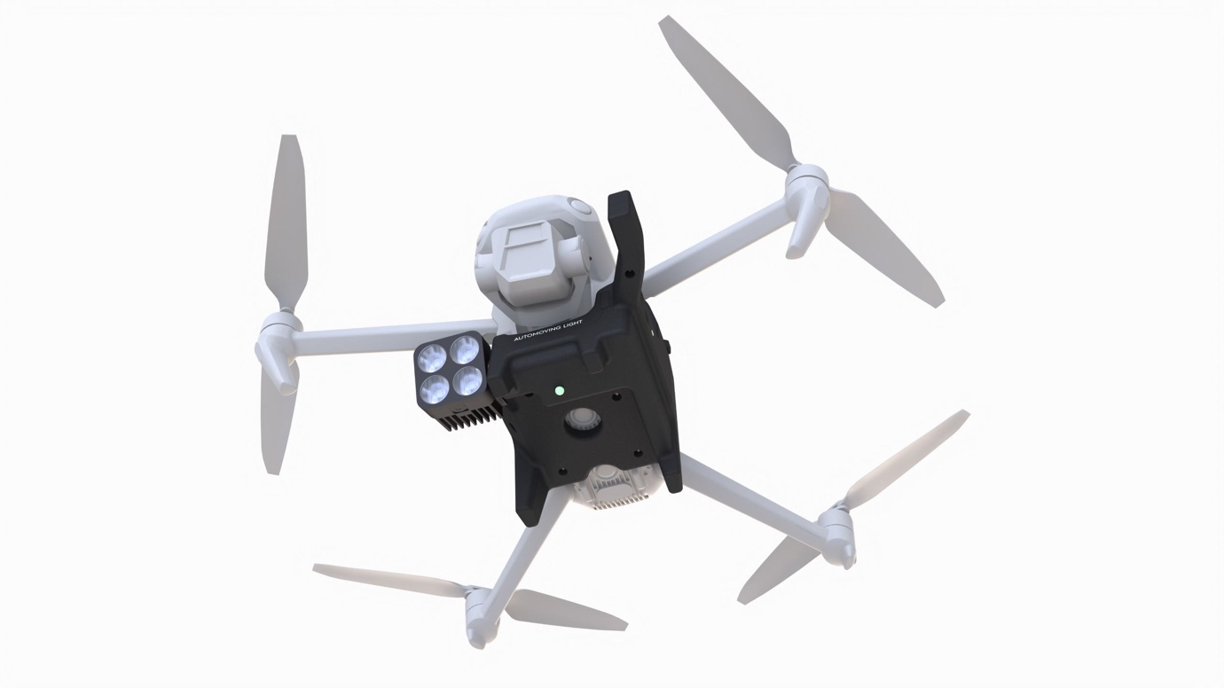
Image: Tundra Drone Automoving light for DJI Mavic 3, Mavic 3E and Mavic 3T.
Credits: Tundra Drone AS

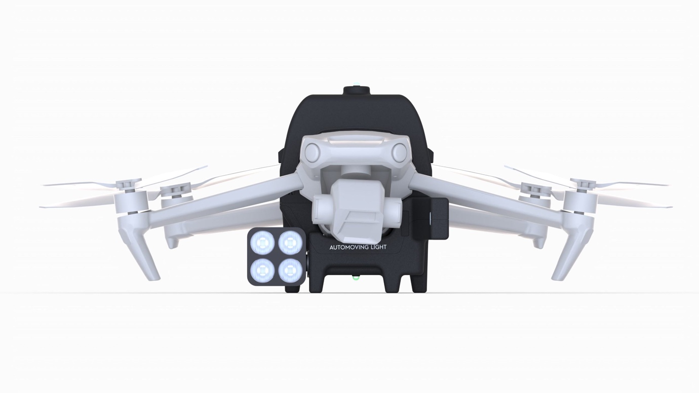
Image: Tundra Drone Automoving light for DJI Mavic 3, Mavic 3E and Mavic 3T.
Credits: Tundra Drone AS

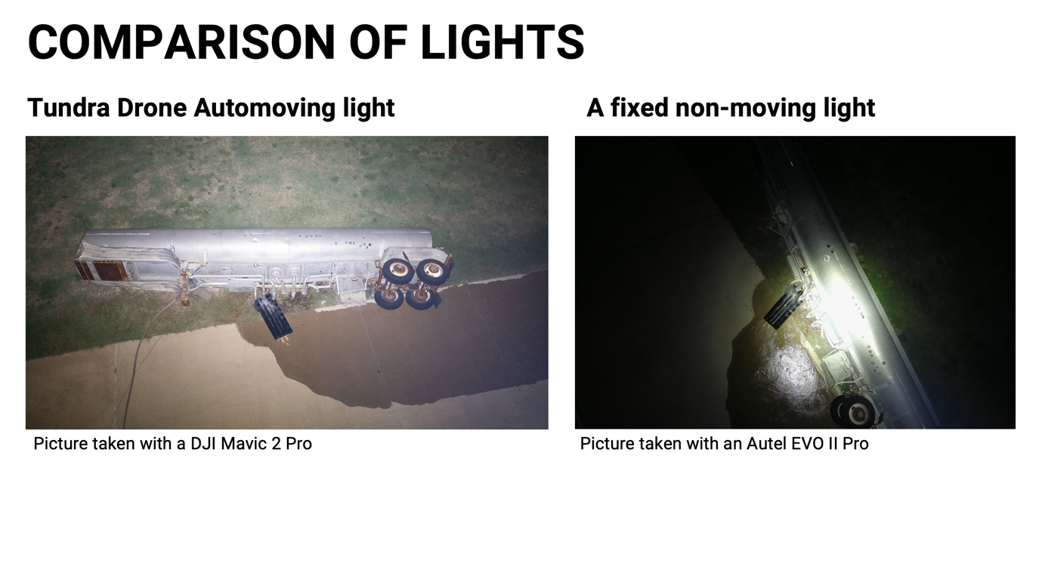
Image: Comparsion of lights
Credits: Tundra Drone and a US public safety agency

Logo:

